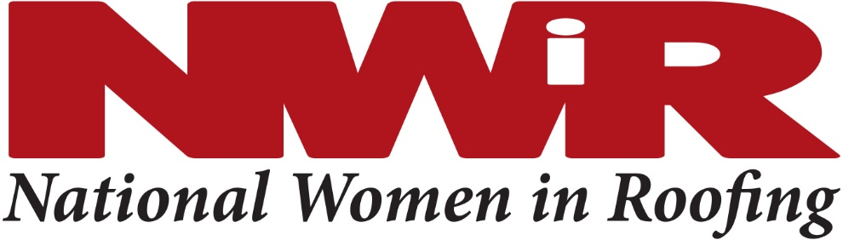
Council Leaders Call
April 6, 2021

Agenda

- “Go to Meeting” invite is on the Outlook appointment
- Quick Intros of BOD members/Staff on the call
- Roll Call of Council leaders on the call
- Updates from NWIR HQ – Association Management
  - Association management company – CIVICA Management
  - Inter-Industry Relations
  - Phone Answering Service, 303-450-3150 (details on the Contact Us page)
- Finances
  - How much money does our council have? … Link to financial reports on the Councils for Resources for page
  - How to get money … on the Councils for Resources for page
  - How to pay for stuff … on the Councils for Resources for page
  - Q4 reports posted
  - New process for getting invoices to sponsors – on the Councils for Resources for page
- Sponsorships
  - Councils may recruit for any sponsor level and will receive $1000 for any sponsor they bring to NWIR in the Diamond, Platinum, Gold, or Silver levels. Sponsor info here: https://nationalwomeninroofing.org/sponsorship/
- Upcoming Events
  - All on the website calendar
  - Roofing Is Connection
  - Tech Talks
- Newsletter – submit through website
- Updates from the Board of Directors (Karen Edwards and Christine Mockenhaupt)
  - NEW – Council LinkedIn pages … social media overview
  - WORLD Award info is live! https://nationalwomeninroofing.org/about-us/world-award/
  - Contacting lapsed members….
    - Membership Committee is contacting people who are not part of a council
    - Council leaders are encouraged to review the list and contact their council leaders who have lapsed
    - Access to member lists by state is through the Resources for Councils page
- From the NWIR Committees…
  - Volunteer leaders needed on the national committees. Descriptions and contact information here. https://nationalwomeninroofing.org/committees/
  - Membership
  - Community Outreach
    - Toolkit on website https://nationalwomeninroofing.org/community-service/
  - Communications Update
    - Link to new submission form on the website under Resources for Councils. Please submit by the 1st of each month, either a recap of a past event or a notice of an upcoming event. If you don’t have anything to submit, please visit the link anyway and click the checkbox at the end that indicates you don’t have a submission. http://nationalwomeninroofing.org/councils/resources-council-chairs/
  - Diversity, Equity & Inclusion
    - Several NWiR members have done a 21 day DEI program and it has been very well received! https://www.unitedwaydm.org/equity-challenge
  - Education
    - hold
  - Membership
    - hold
  - Mentoring
    - Toolkit: https://nationalwomeninroofing.org/mentoring/
  - NWIR Day
    - official 4th Annual NWiR Day will be August 8 in Las Vegas
  - Recruitment

- Event recaps
  - We want to encouraging virtual council meetings - https://nationalwomeninroofing.org/wp-content/uploads/2020/03/Implementing-a-Virtual-Council-Meeting.pdf
  - Use the Meeting Ideas on the Resources for Councils page for ideas
- Questions
- Next Calls:
  - Every Tuesday at 3pm ET

Resources for Council Chairs webpage – everything starts here!
nwircouncilsinc2016

