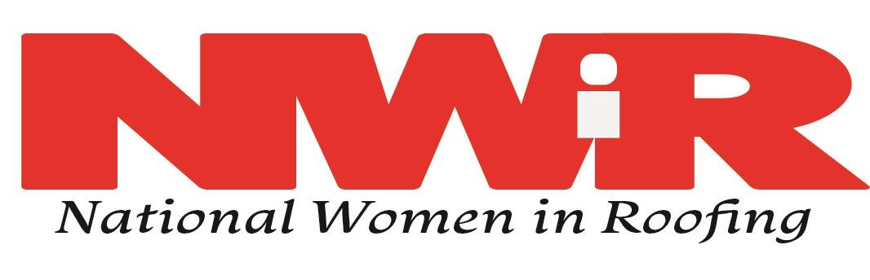

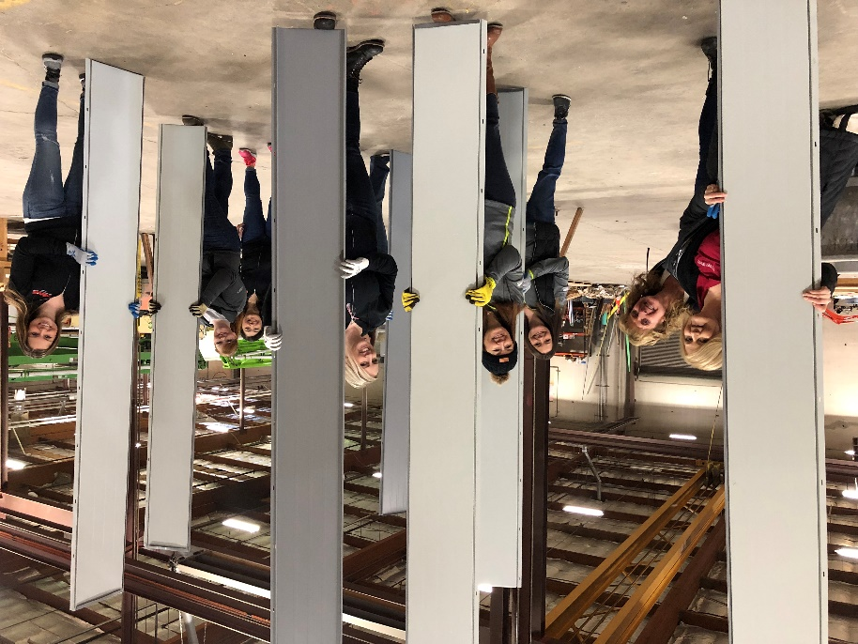
National Women in Roofing (NWIR) is a volunteer-based organization that supports and advances the careers of women roofing professionals. We provide networking, mentoring, education and recruitment opportunities from the rooftop to the boardroom, for the young professional at the start of her career to the seasoned manager in the executive suite.
Our focus is on connecting and empowering women so that their training and leadership skills can help drive the overall betterment and professionalism of the roofing industry. Our membership also includes and welcomes men who support the inclusion of women in the roofing industry. Working together, we are bringing the industry to a new level of excellence by supporting and promoting the contributions of women as an essential component to the future of roofing.

NWiR strives to support “Women in Crisis” and women empowerment social causes and community service opportunities through national, regional and local support, awareness and partnership. The Community Service Committee works as the liaison between NWiR, councils and other agencies, charities, and service organizations to advance philanthropic efforts.
Committee members help councils choose community service activities, raise funds for charity and communicate successes. They offer education and encouragement on how to fundraise and encourage volunteerism for local women shelters, women crisis centers, women build programs and more.

